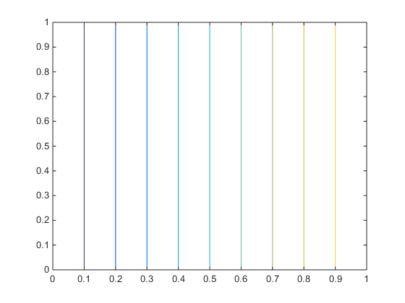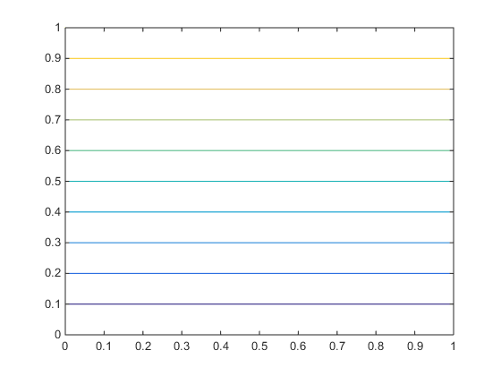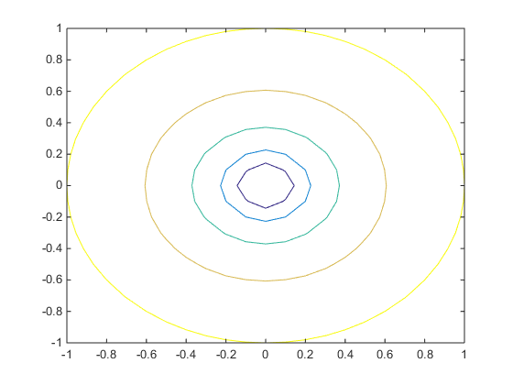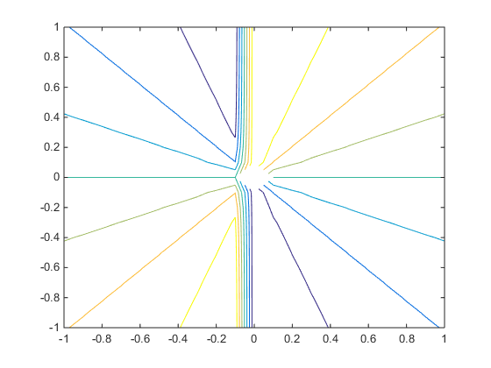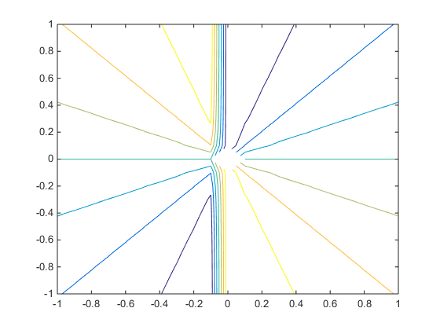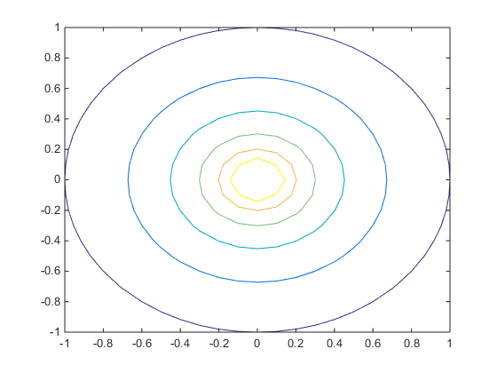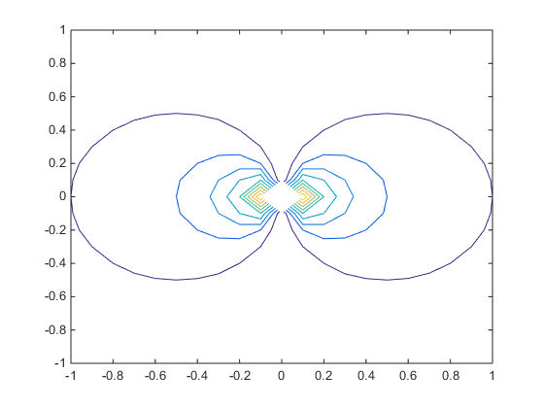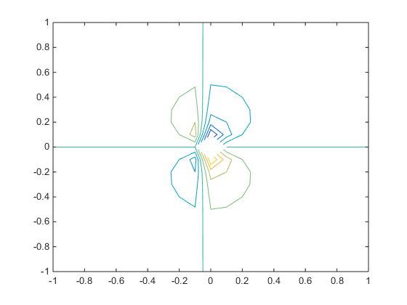

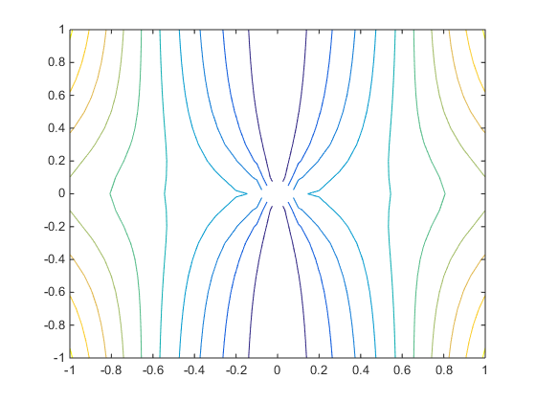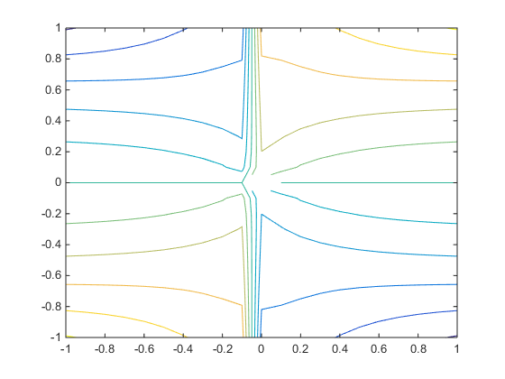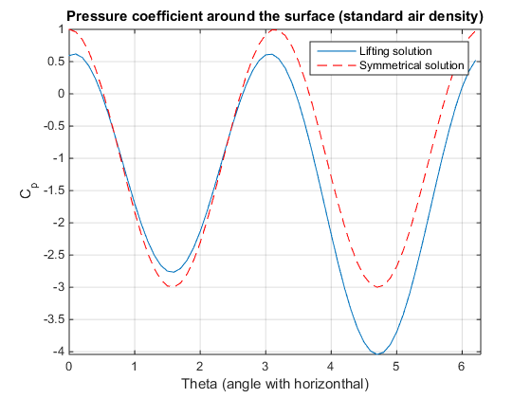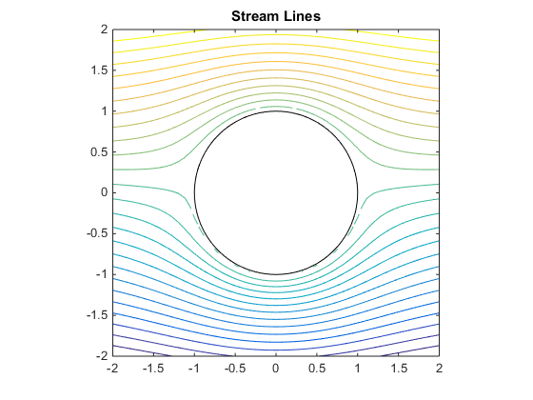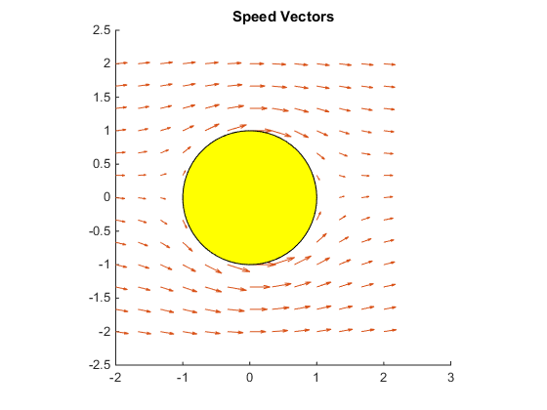

REFERENCES:

* <https://in.mathworks.com/matlabcentral/fileexchange/4674-streamlines---magnus-and-cp-aroud-a-cylinder-section>
* [www.mdp.eng.cam.ac.uk/web/library/enginfo/aerothermal_dvd_only/aero/fprops/poten/node37.html](http://www.mdp.eng.cam.ac.uk/web/library/enginfo/aerothermal_dvd_only/aero/fprops/poten/node37.html)
* <http://nptel.ac.in/courses/112104118/lecture-23/23-2_flow_rotate_cylinder.htm>
* <http://nptel.ac.in/courses/112104118/lecture-21/21-1_free_vortex_flow.htm>